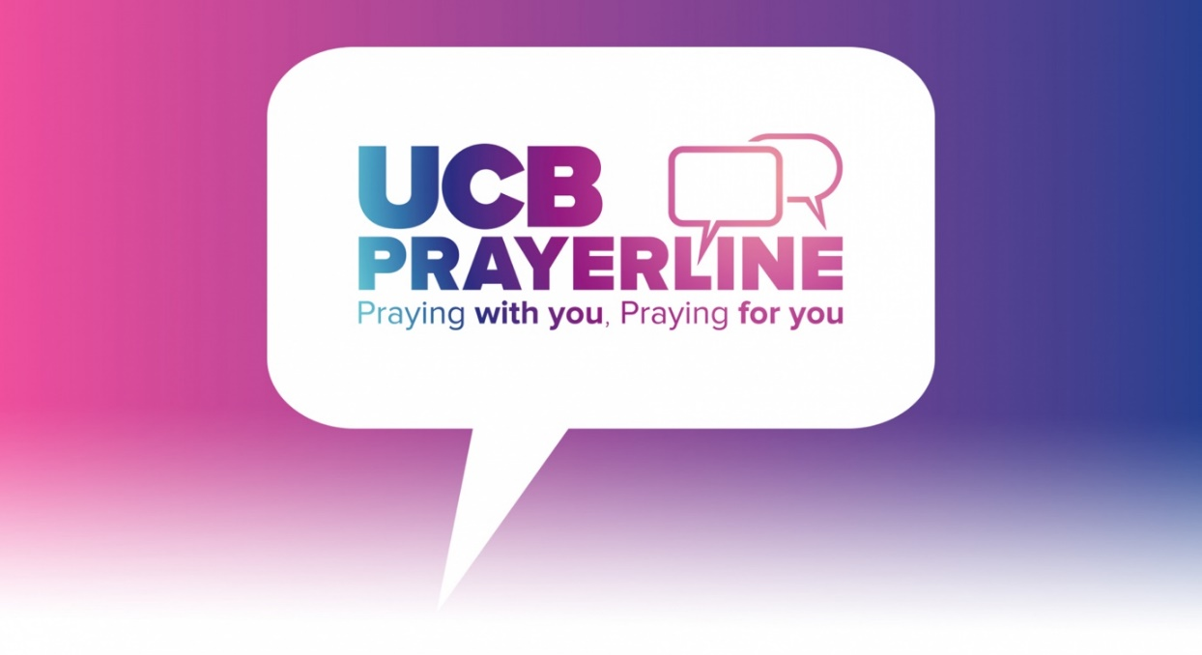
Volunteering with UCB Prayerline
“I have been a Prayerline volunteer for a number of years.
I have received far more than I have given.”

We are thrilled that you are interested in finding out more about being a Prayerline volunteer! Ringing the Prayerline service seems like such a simple thing, but that single phone call can make all the difference in the world. The amazing thing about Prayerline is that no matter how alone a person feels, we are only a phone call away. Many of our callers describe Prayerline as a lifeline for them. We are not a counselling or advice service. We pray, using Scripture. It has power. Is this something God is calling you to?

There is a job description and application form on our web-site, or feel free to contact us at any time. Here are some of the questions you might have.

Can I volunteer from home?
Yes! Volunteering with Prayerline can be done from anywhere. We have ensured that it is possible for anyone to answer calls from the comfort of their own home. You can also volunteer to pray over email and postal prayers from your own home, too.

How much time will be required?
We ask that volunteers commit to a minimum of two hours a week on the phones and voluntarily engage with other Prayerline events offered. Some experienced volunteers are happy to cover more than one shift in a week when additional cover is needed.

Can I choose what time I am available?
Each volunteer covers the same regular time period each week. This will be discussed with you after training to establish both your availability and the covering of times when people are most likely to call. We realise that plans can change , so your time assigned may not be able to be sustained in which case we can arrange to accommodate a change of time for you, should the need arise. We know that plans can change, so we try to find cover for volunteers who become unavailable.
What is the difference between Prayerline and other helplines?
Prayerline is not a listening or counselling service. There are other services who do this with excellence. We are there to pray for people, often for one specific need, using Scripture.

What experience do I need?
You do not need to have prayed for people over the phone before, but you do need to be a practicing Christian, mature in faith and personal standing within your church community. You will be someone who has experience using Scripture in the context of one-to-one pastoral prayer. It is crucial that you understand the complexities and vulnerabilities of different personal situations. At UCB we take seriously our responsibility to safeguard vulnerable adults, and the confidential nature of the Prayerline service. There is a more detailed job description here.

What is the process for becoming a volunteer?
First, read the job description. Pray about it, and if possible ask the advice of your church leader or a Christian friend. There is an application form here, which includes a request for references. After this you will be contacted about next steps.

What training and support is given?
For those who are accepted into the first stage of becoming a volunteer, you will be enrolled in a programme of induction training. This mainly takes place over Zoom and video, but you may also be invited to in-house training. You will speak with our Prayerline team. You’ll be contacted before and after each of your volunteering sessions as you learn the role. During every call you will have a UCB staff member on hand for any technical difficulties, questions or support need. There are also optional volunteer prayer and praise evenings, social media groups and get together, and you will have access to UCB’s broader prayer and ministry training. We are alongside you all the way.

Who calls up?
All kinds of people call the Prayerline service. At Prayerline we have an unbiased and open attitude to the culture and opinions of others. Our main desire on each call is to pray with people, using Scripture. Many ask for a prayer for healing. Others want prayer for a difficult situation or relationship. Some are in a crisis or are lonely. Some want to share an answer to prayer. Some have mental health challenges, and need compassion and support. We provide ongoing support for you in answering calls, especially the more difficult calls.

Why should I be a Prayerline volunteer?
Perhaps you are have been described as a ‘prayer warrior’. Could you pray for those you don’t know and cannot see?
Perhaps UCB has had a huge impact in your life, and you have benefited from the prayers of others.
Perhaps you know what it is to serve, and you know God is calling you to this.
Perhaps you are keen to grow in prayer, receive training and become better supported at praying for others.
Perhaps you have professional or other skills, and you want to use them to pray and serve in this way.

As a Prayerline volunteers you will:
- give hope and solace to callers
- grow in your use of Scripture in prayer
- be stretched in your prayer life, and will grow spiritually
- be part of a network of volunteers and UCB staff with the same calling and compassion
- experience God speaking to you and to the callers through His Spirit
- be one of those ready to respond as God moves in the UK!

What difference does it make?
Prayerline transforms lives. There are more than 100,000 calls a year, and often more than 500 a day. You will be playing a key part in responding directly to spiritual, mental and social need. The work is often hidden. It is personal. But it is profoundly meaningful and powerful.

What do people say about being a Prayerline volunteer?

“It is a sacred place for me to escape into, get refreshed, get refined. It has helped my Christian journey and changed my prayer life. It’s about trusting God, no matter how deep or overwhelming the situation is, as people present what they are going through.”

“Prayerline has given me the privilege of praying with people from different cultural backgrounds. It's been a wonderful humbling experience for me.”

“My anticipation is to see God glorified. And people say thank you: there are so many people who appreciate what we do!”

“After you've prayed some will say ‘you've brought me into a different perspective, it’s given me peace’. Not every time, but that's the thing I look forward to. God's word brings life and brings a light into a dark place.”

“I appreciate the privilege of praying with people and blessing them. I’m also improving my knowledge of the Bible!”

“I have been a Prayerline volunteer for a number of years. I have received far more than I have given.”
Find out more: Read the job description here Apply here

