Modern Slavery

Introduction
This article builds on the previous one, (published in Apr 2022) which outlined what Modern Slavery is. The core of which is deception, often accompanied with violence to ensure that slaves remain compliant. This article explores detection and the tell-tale signs of Modern Slavery.

Typical Victim and types of Modern Slavery
To address Modern Slavery we need to be observant and must know what signs to look for. However, before considering detection and tell-tale signs it is worth looking at a typical victim and the types of modern slavery.
Well, actually there is no typical victim. Modern slaves can be of any age, race or gender.
There are three main types of Slavery, these are:
- Labour Exploitation
- Sexual Exploitation
- Domestic Servitude
Additionally, there are other types which should be recognised and include:
- Organ Harvesting
- Debt Bondage
- Forced Marriage
- Financial Exploitation
- Criminal Exploitation
An example of which is County Lines which is one of the most prevalent forms of Criminal Exploitation. This is where drug dealers from large cities drive out local drug dealers in smaller towns and exploit children and vulnerable people to sell drugs. Children are groomed and then once caught up in this evil trade are exposed to violence or threat of violence to ensure they remain compliant to what is being asked of them. The perpetrators prey on marginalised children who have often been let down by multiple agencies.

Detection and Tell-Tale signs
Tell-tale signs may be apparent in:
- Physical appearance
- Workplace
- Accommodation
When put together these signs could highlight possible Modern Slavery concerns. Taking each category in turn:
- Physical appearance: victims may:
  - have injuries that appear to be the result of assault
  - look malnourished
  - be withdrawn
  - have poor hygiene
- Workplace: victims may:
  - Work excessively long hours over lengthy periods
  - Not have any days off
  - Wear the same clothes everyday
  - Always be supervised
  - Never leave the workplace alone
  - Rarely interact with other workmates
- Accommodation
  - If a house is overcrowded with young men, this could be a sign of labour exploitation.
  - If overcrowded with young women, this could be a sign of sexual exploitation.
- Sadly, young people can be victims of modern slavery, as with County Lines and some of the tell-tale signs are:
  - Unexplained new possessions
  - Driven around by unknow adults
  - New designer clothes
  - Truancy
  - Injuries

Pause and Reflection
Biblical Reflection based on Matthew 22 v34-40.
Who is my neighbour?
- The refugee, escaping from a war-torn homeland and ends up in Domestic servitude, or worse.
- The homeless young man who ends up in Labour exploitation.
To consolidate the points outlined in this article and to put them in context, if you are able, please watch the film (see details below) about a young man who leaves home and then gets caught in Modern Slavery. In particular, please look out for:
- How the victim became so vulnerable
- The offer of help by the perpetrator
- The type of work he was expected to do and the training given
- The threat of violence
- The outcome
https://theclewerinitiative.org/stories/charlies-story

Further Information and contact details

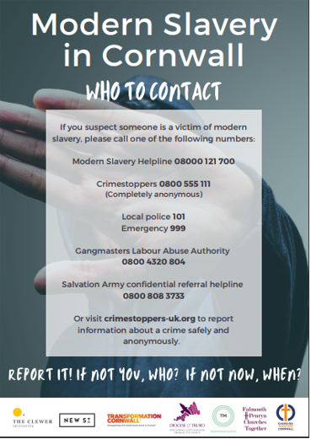
Modern Slavery is an increasing problem and the Transformation Cornwall website provides a comprehensive list of available resources. Please visit the site at the link below:
https://transformation-cornwall.org.uk/initiatives/a-modern-slavery-initiative
The next article will explore opportunities of Preventing Modern Slavery.
The Modern Slavery in Cornwall Network – May 2022

